NaPDI Repository Data Entry SOP: In vitro Enzyme Kinetic Studies

Version 1

Creation Date: March 2017

Author: Jingjing Yu

**Contents**

**1. Background………………………….………………………………………………………………………………...…2**

**1.1 Scope……………………………………….………………………………...………………………….…..……2**

**1.2 Definitions…………………………………………….………………………………………………………..2**

**2. Creating a Study……………………………………………………………...………………………………...………3**

**3. Study Page………………………………………………………………………………………….………...…...………4**

**4. Experiment………………………………………………………………………………………………..…...…………6**

**5. Experimental Conditions…………………………………….…………………………………………..………..8**

**6. Results…………………….………………………………………………………………………………………………10**

**…. To update page numbers…**

# Background

* 1. Scope

The purpose of this SOP is to describe how to enter *in vitro* enzyme kinetic study results into the NaPDI repository. The information entered in the repository is from the summarized Study Report. Natural Products (NPs) are expected to be evaluated as objects of drug-metabolizing enzymes.

Most of the information entered in the repository will come directly from the study report. However, several text fields are provided throughout the admin site to allow the addition of relevant comments that may pertain to the experimental study design and conditions, the study results, and/or the mechanism and clinical relevance of the interaction. This additional information should be reviewed with the principal investigators during the validation process as it will be used to enrich the users experience and understanding of the clinical results.

* 1. Definitions

Add user-centered definitions (alphabetically)

# Creating a study

Use the following steps to create a new study.

* 1. Navigate to the Admin page of the NaPDI Repository

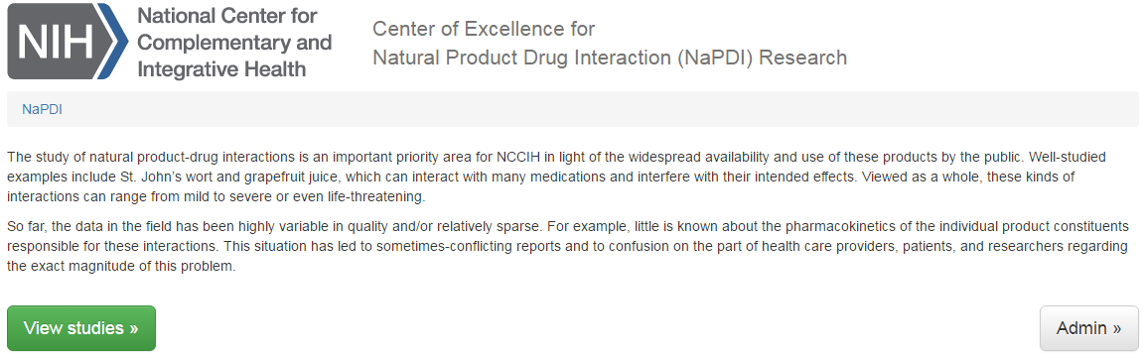

* 1. Using the admin page, click on “Studies”

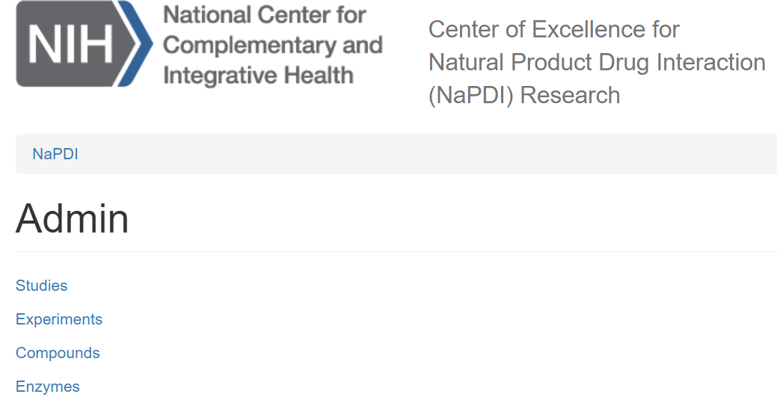

* 1. then, click on “Add new study”

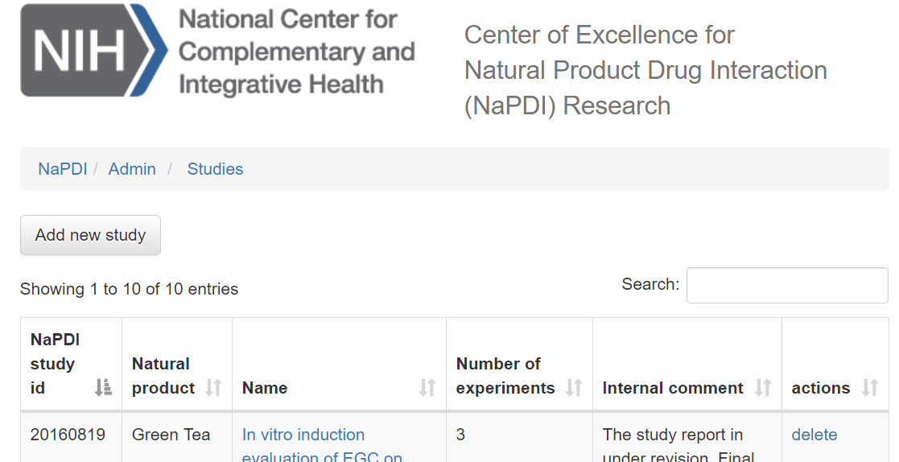

# Study Page

A study can only accept data from one Natural Product and one species. For example, *in vitro* data with Licorice *Glycyrrhiza glabra* L*.*, *Glycyrrhiza uralensis* Fish have to be reported in two different studies, one for each Licorice species.

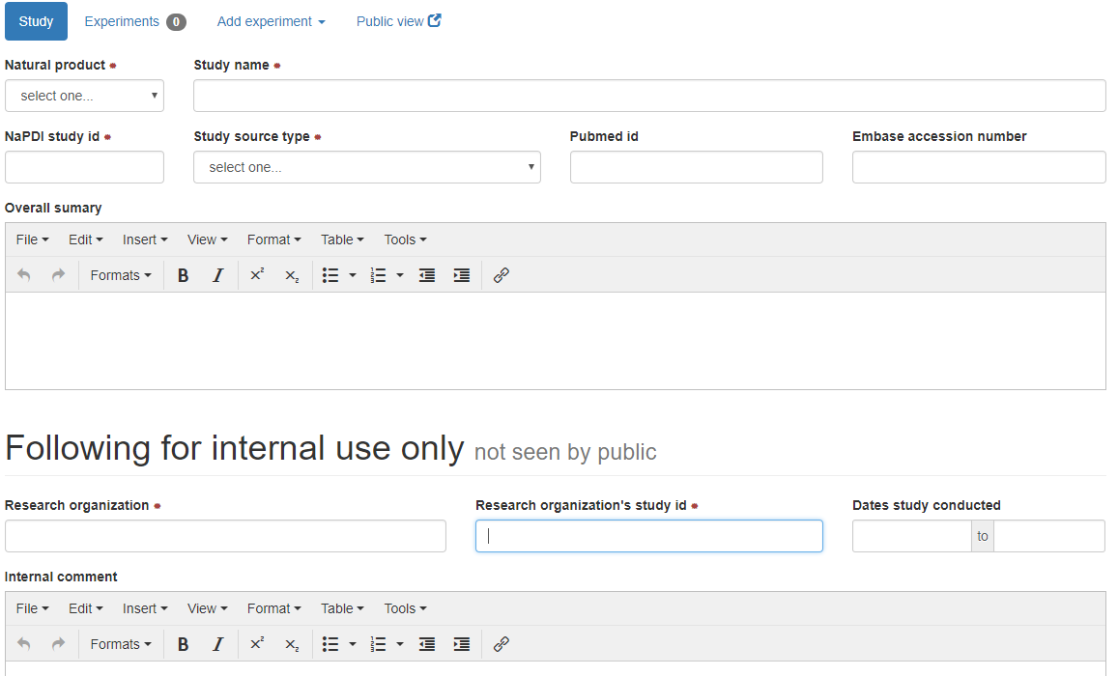

* 1. Select the **Natural Product** tested in the *in vitro* screen study from the drop down list provided (select one; required).
  2. Enter the **Study Name** as presented in the Study Report (required).

If a entries originate from a published paper, used the Pubmed ID or Embase PUI as the NaPDI Study ID (e.g., “PMID:23268924”)

* 1. Enter the **NaPDI Study ID** as presented in the Study Report(required).
  2. Select the **study source type** or source from which the study was obtained (required).
* Published report
* Manuscript prepared or submitted for peer-reviewed publication
* Unpublished data submitted through a NaPDI form
  1. Enter the **PubMed ID** and/or **Embase** **Accession** numbers, only if the study has been published (optional).

If entries are from a published paper, copy and paste the abstract into the Overall summary box.

* 1. **Overall summary**: this summary should provide a concise overall conclusion of the *in vitro* study and also discuss the possible mechanism(s) involved.
  2. The **Following for internal use only** section is designated for internal notes and will not be displayed to users.
     1. Enter the **Research organization** name (required).
     2. Enter the **Research organization’s** **study ID** (required).
     3. Enter the dates the study was conducted under **Dates study conducted** (optional). If only months are provided, select the first and last days of the month for the starting and ending date, respectively. For example, March to April, 2017 will be entered as 03/01/2017 to 04/30/2017. **d**
     4. Enter **Internal comments** associated with the study that are intended for internal use only (optional).
  3. Select the **status** of the current study entry
* Draft – selected when the curator is in the process of entering the data or checking the data
* Pending review – selected when the study had been fully entered by the curator and needs to be reviewed and validated by a second editor
* Published – selected after validation and is ready for public display

# Experiment

After a study has been created, use the following steps to add a new experiment.

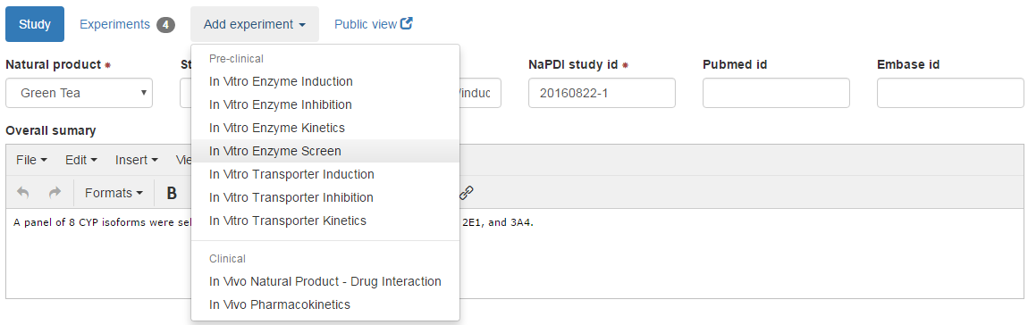

* 1. Click on **Add experiment**, and then select **In Vitro Enzyme Kinetics** from the drop-down menu (select one; required).

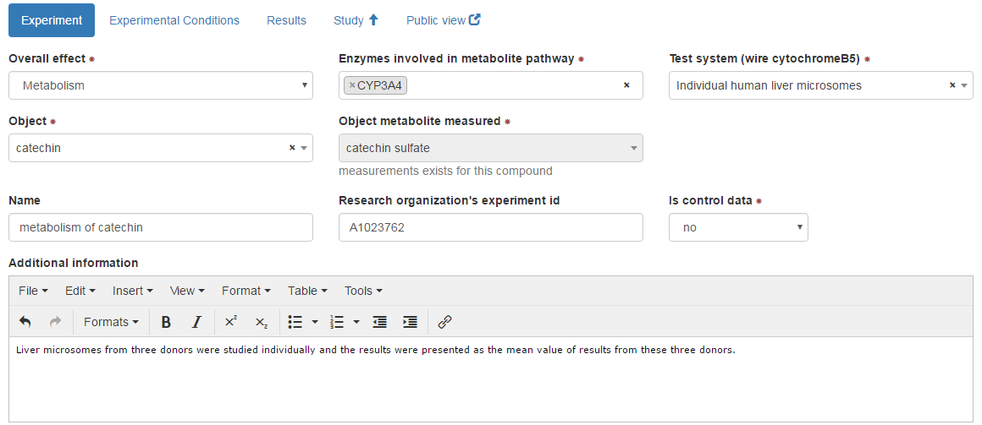

* 1. Select the **Overall effect** (select one; required) from the drop-down list. Select the only available option “Metabolism”.
  2. Select **Method for determination of overall effect** (select one; required). Select if the study is a Parent Disappearance Study or Metabolite Formation Study (required).
  3. Select the **Enzyme(s)** **involved in metabolite pathway** (select many; required).All enzymes that are responsible for the formation of the metabolite (if specific formation of metabolite is measured) or parent disappearance (if parent disappearance is measured) should be selected. Multiple selections can be made. When variant enzymes are studied, select the variant enzyme and specify the variant in the **Additional information** text box (see below).
  4. Select the **Test system** from drop-down list (select one; required).

Notes:

1. For **recombinant expression systems**, appropriately select **Cytochrome b5** conditions: select “Yes, co-expressed” if Cytochrome b5 was used and co-expressed in the recombinant system; select “Yes, supplemented” if Cytochrome b5 was used and was supplemented in the incubation; select “No” means Cytochrome b5 was not used; select “Not available” if conditions regarding Cytochrome b5 were not provided in the Study Report.
2. If a study used a few donors of human liver microsomes, but each donor was evaluated individually, and results were presented as the mean value from all the donors, select “pooled” source and comment it in the **Additional information**.
3. When other cell lines or test systems than those listed in the drop-down menu are studied, select “Other cells” and specify the variant cell line or test system in the **Additional information** section.
   1. Select the **Object** from the compound list (select one; required). If the compound is not listed, follow the SOP to create the compound.
   2. Select **Object metabolite** measured from the compound lists (select one; required).
   3. Enter an experiment **Name** if necessary (optional). Use title case, where the first word and all major words are capitalized, e.g. Catechin Kinetics by CYP3A4 using Recombinant Enzyme. Experiment names are used as sub-headings in the public view; therefore, names that describe the object and metabolic pathway in the study are best suited for this purpose.
   4. Enter the **research organization’s** **experiment id** if the information is provided from the Study Report (optional).
   5. Select “yes” from the **Is control data** drop-down menu if this data corresponds to the control experiment for the study (select one; required); Otherwise, select “no” (required). The “Is control data” function allows experiments to be linked within the repository. It only appears on the admin side and not the public view.
   6. Enter **Additional information** important to the data obtained from this experiment, but the details were not included in the fields above (optional). If reporting a vehicle control, enter the details regarding the positive/negative control in this section. Relevant information can be but not limited to: variant enzymes, other enzymes, or test systems that are not listed in the drop-down menu; the way that the objects were prepared, etc. If reporting a vehicle control, enter the details regarding the positive/negative control in this section.

# Experimental Conditions

Enter experimental details that are provided in the study report. None of these fields provided are set up as required. In many cases, some of them may be left blank.

When entering conditions from published literature that refer to experimental conditions described in a reference, check the reference for conditions that are not clearly stated in the article. For example, if an article states that CYP1A2 substrates and concentrations used in Vivid CYP screening assays were used as described in Cheng et al. and the authors do not describe any further details, check Cheng et al. for experimental conditions and enter those stated therein. Also, make a comment in the additional information section regarding which parameters were extracted from the reference citation (*e.g.*, Object and object concentrations tested were extracted from Cheng et al., 2017).

* 1. Enter **Cell density** in scientific notation (optional). Specify the units and the type of culture plates or dishes used, e.g. 5 x 10^5 cells/well (12-well plates); 1 x 10^6 cells/mL in suspension
  2. Enter **Protein concentration** (optional).Use the unit presented in the Study Report. If a protein amount and volume used are provided, calculate the concentration by dividing the amount by the volume (*e.g.*, 0.1 mg/0.5 mL = 0.2 mg/mL)
  3. Select **Test system preparation** from the drop-down menu (select one; optional). If the test system used was prepared in house, select “In-house preparation”; if the test system used was purchased from a commercial vendor, select “Commercially available”.
  4. Select **Test system lot number** if the test system was commercially obtained (optional).
  5. Enter **Incubation volume** (optional). Specify the units as presented in the Study Report. If volumes were listed in steps, the total incubation volume may be calculated by adding the volumes of each step (*e.g.*, 100 µL buffer + 10 µL NADPH + 90 µL compound tested = 200 µL total volume).
  6. Enter **Incubation time** (optional). Specify the units as presented in the Study Report. This duration implies the presence of all necessary components of the incubation (*i.e.*, the enzyme, the object, the precipitant, and if used, co-factors).
  7. Select **Co-factors** from the drop-down listif applied (select many; optional). Multiple co-factors may be selected as needed.
  8. Select **Co-substrates** from the drop-down listif applied (select many; optional). Multiple co-substrates may be selected as needed.
  9. Make selections for **Protein linearity** from the drop-down menu (select one; optional). Select *“Available”* if linearity of metabolite formation or parent disappearance with regard to protein concentration is tested; select *“Not available”* if no such information is provided in the Study Report.
  10. Make selections for **Time linearity** from the drop-down menu (select one; optional). Select “Available” if linearity of metabolite formation or parent disappearance with regard to incubation time is tested; select “Not available” if no such information is provided in the Study Report.
  11. Enter **Object concentration tested** (optional). Specify the units as presented in the Study Report. If concentration is not described in the text but presented from figures, enter the concentration and specify the source, *e.g.* 1-100 µM (estimated from Fig. 3).
  12. Enter **Additional information** as needed. Any additional information that is important to the experimental conditions, but were not detailed in the fields above can be entered in this field. If reporting a vehicle control, enter the details regarding the positive/negative control in this section. Relevant information can be but not limited to solubility issues of the object; … (more examples to be added)

# Results

* 1. Use the **Add measurement** function to add a new measurement to the table of results.

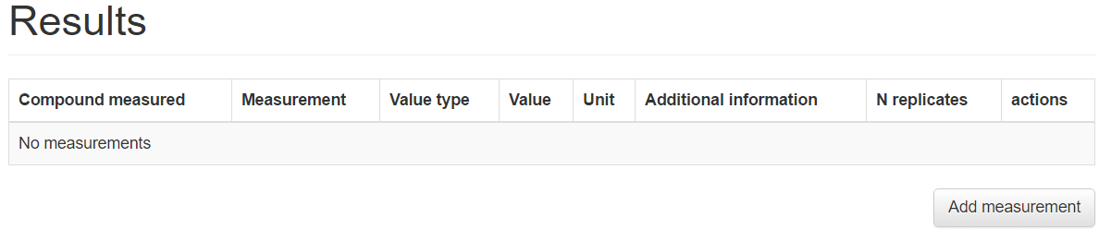

The object compound (or metabolite) name selected in the experiment page will automatically be populated in the **Compound measured** field.

* 1. Select a **Measurement type** (select one; required) from the drop-down list, the associated **Unit** (select one; required), and the **Value type** (select one; required)based on the avaliable data in the Study Report. Use separate entries for each type of measurement.
     1. Avaliable **Measurement type** includes “Km” , “Vmax”, “CLtotal”, “CLunbound”, and “Percent Bound”.
     2. **Value type** (select one; required)– based on the Study Report choose mean, median, or single value (mean or median is not specified) for the parameter to be entered. Before the value field, select “>”, “≥”, “<”, or “≤” when provided in the Study Report; “=” is the default if no selection is made.
     3. **Variability** (required) –enter the standard error of the mean(**SEM**), percent coefficient of variation (**%CV**), standard deviation (**SD**), 90% or 95% confidence interval (**90% CI**, **95% CI**) or **range** associated with the value.
     4. Enter the total number of **(N) replicates** (required) used in the study (e.g., enter 1 when only one test was conducted, 3 when a total of 3 replicates were used, etc.).
     5. When statistical tests are conducted, select a significance level of the **P value** tested or **not significant** (optional)when the null hypothesis is true. If the authors give a P value that is not avaliable in the drop-down menu, chose the level of significance that is true (e.g., if P = 0.0009 in the Study report, choose P < 0.001).
  2. When all measurements have been entered for that entry, click **Add**.

Snapshot here

* 1. **Additional Information:** as needed, add any other information that is important to the result, but that were not detailed in the results table. For example, **…** If reporting a vehicle control, enter the details regarding the positive/negative control in this section.

Click to save the entries.

After submitting the study entry, it can be viewed as it will appear to the public by clicking on the “Public View” function near the top of the page.

Note regarding units: For consistency use the following abbreviations for the specified units below. If a unit is not listed below, use the units specified in the Study Report.

|  |  |
| --- | --- |
| Unit | Abbreviation |
| hour(s) | h |
| minute(s) | min |
| second(s) | s |
| day(s) | day(s) |
| liter | L |
| per unit | /unit (*e.g.*, /min) |
| micro | µ |
| fold | -fold (*e.g.*, 3.2-fold) |
| exponents | ^ (*e.g.*, 10^-6) |
| less than, less than or equal to | < , ≤ |
| greater than, greater than or equal to | > , ≥ |
| plus or minus | ± |

* Use molar concentration rather than moles per liter(i.e., use µM rather than µmol/L). In the case of natural products, the use if grams per liter (i.e., µg/mL) may be necessary.
* Do not convert gram concentrations (*e.g.*, µg/mL) to molar concentrations (*e.g.*, µM), even if the molecular weight of the compound is provided.
* If the units provided for a given field are different from the units in its corresponding drop-down menu, convert the units provided in the study report to the units provided in the drop-down menu. If this is not possible (for example, µg/mL cannot be converted to µM for natural product mixtures because there is not a molecular weight available for the conversion), add the new unit to the drop-down menu.